HW5

Qiuying Li UNI ql2280

10/12/2017

1. Determine whether there is a significant difference in the mean weights of the six diet groups, using a one-way ANOVA

#a) Without adjusting for Week 3 weight  
library(devtools)  
install_github("pda", "byandell")

## Warning: Username parameter is deprecated. Please use byandell/pda

## Skipping install of 'pda' from a github remote, the SHA1 (2e37cdb4) has not changed since last install.  
## Use `force = TRUE` to force installation

library(pda)

## Loading required package: MASS

## Loading required package: lattice

## Loading required package: lme4

## Loading required package: Matrix

library("lsmeans")

## Loading required package: estimability

##   
## Attaching package: 'lsmeans'

## The following object is masked from 'package:devtools':  
##   
## test

diet <- Diet  
diet$trt <- factor(diet$trt)  
diet$block <- factor(diet$block)  
anov1 <- aov(dmi ~ trt, diet)  
summary(anov1)

## Df Sum Sq Mean Sq F value Pr(>F)  
## trt 5 22.7 4.548 0.723 0.609  
## Residuals 51 320.9 6.292

#Adjusting for Week 3 weight.  
library(lsmeans)  
#library(car)  
lm.adjust<-lm(dmi~covar+trt, data = diet, na.action=na.omit)  
anova(lm.adjust)

## Analysis of Variance Table  
##   
## Response: dmi  
## Df Sum Sq Mean Sq F value Pr(>F)   
## covar 1 97.510 97.510 21.8963 2.38e-05 ***  
## trt 5 32.074 6.415 1.4405 0.227   
## Residuals 48 213.756 4.453   
## ---  
## Signif. codes: 0 '***' 0.001 '**' 0.01 '*' 0.05 '.' 0.1 ' ' 1

summary(aov(formula = dmi ~ covar + trt, data = diet))

## Df Sum Sq Mean Sq F value Pr(>F)   
## covar 1 97.51 97.51 21.90 2.38e-05 ***  
## trt 5 32.07 6.41 1.44 0.227   
## Residuals 48 213.76 4.45   
## ---  
## Signif. codes: 0 '***' 0.001 '**' 0.01 '*' 0.05 '.' 0.1 ' ' 1  
## 2 observations deleted due to missingness

lm.rg<-ref.grid(lm.adjust)  
ls.adjust<-lsmeans(lm.rg,"trt")  
ls.adjust

## trt lsmean SE df lower.CL upper.CL  
## 1 26.29123 0.7533018 48 24.77662 27.80585  
## 2 26.04920 0.6677277 48 24.70664 27.39176  
## 3 25.28964 0.7111383 48 23.85980 26.71948  
## 4 24.98696 0.6711554 48 23.63751 26.33641  
## 5 23.95214 0.7473029 48 22.44958 25.45469  
## 6 24.66415 0.6691888 48 23.31865 26.00964  
##   
## Confidence level used: 0.95

#Use a test for parallelism to evaluate the appropriateness of performing inference based the adjusted means.  
dmi = diet$dmi  
covar = diet$covar  
trt = diet$trt  
summary(aov(dmi ~ covar*trt))

## Df Sum Sq Mean Sq F value Pr(>F)   
## covar 1 97.51 97.51 20.745 4.29e-05 ***  
## trt 5 32.07 6.41 1.365 0.256   
## covar:trt 5 11.64 2.33 0.495 0.778   
## Residuals 43 202.12 4.70   
## ---  
## Signif. codes: 0 '***' 0.001 '**' 0.01 '*' 0.05 '.' 0.1 ' ' 1  
## 2 observations deleted due to missingness

#When Ho is rejected, inference about the marginal mean differences must be performed for each X = x

anov1 <- aov(dmi ~ trt, diet)  
anov2 <- aov(dmi ~ trt + covar, diet)  
par(mfrow = c(1,2))  
hist(resid(anov1))  
qqnorm(resid(anov1))

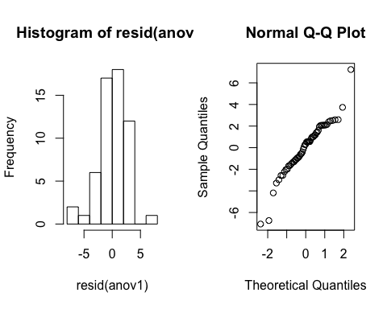

shapiro.test(resid(anov1))

##   
## Shapiro-Wilk normality test  
##   
## data: resid(anov1)  
## W = 0.95225, p-value = 0.02491

par(mfrow = c(1,2))  
hist(resid(anov2))  
qqnorm(resid(anov2))

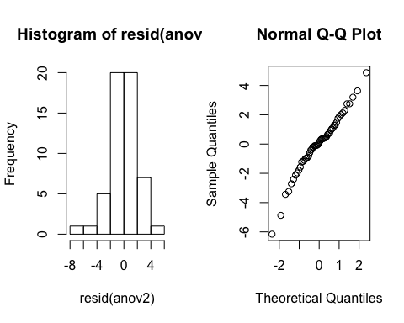

shapiro.test(resid(anov2))

##   
## Shapiro-Wilk normality test  
##   
## data: resid(anov2)  
## W = 0.97402, p-value = 0.2772

kruskal.test(dmi~trt,data=diet)

##   
## Kruskal-Wallis rank sum test  
##   
## data: dmi by trt  
## Kruskal-Wallis chi-squared = 3.5168, df = 5, p-value = 0.6209

bartlett.test(x= diet$dmi, g = as.factor(diet$trt))

##   
## Bartlett test of homogeneity of variances  
##   
## data: diet$dmi and as.factor(diet$trt)  
## Bartlett's K-squared = 7.5715, df = 5, p-value = 0.1815

library(car)

##   
## Attaching package: 'car'

## The following object is masked from 'package:pda':  
##   
## ellipse

leveneTest(y=diet$dmi,group=as.factor(diet$trt))

## Levene's Test for Homogeneity of Variance (center = median)  
## Df F value Pr(>F)  
## group 5 0.3959 0.8494  
## 51

library(pwr)  
help(pwr)  
p.func<-function(mean.diff,sd,size=seq(5,10,1)){  
 power = vector()  
 for(k in 1:length(size)){  
 p = pwr.t.test(n= size[k],d=mean.diff/sd,type = "two.sample",alternative = "greater")   
 power[k] = p$power  
 }  
 name = sprintf("sd = %g, mean.diff = %g", mean.diff, sd)  
 plot(size, power, type = "l", xlab = "Sample Size (n)", main= name, ylab = "Power",ylim = c(0,1))  
 axis(side=2, at=seq(0, 1, by=0.1))  
}  
# Plot power vs sample  
par(mfrow = c(2,3))  
mean.diff=seq(2,10,4)  
sd=c(5,10)  
for (j in 1:length(mean.diff)){  
 for (i in 1:length(sd)){  
 p.func(mean.diff[j],sd[i])  
 }  
}

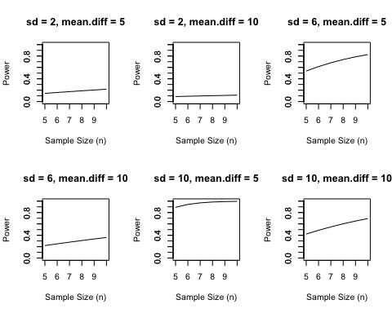

par(mfrow = c(3,3))  
propes.func<-function(p,size=seq(5,10,1)){  
 h = vector()  
 for(k in 1:length(size)){  
 p.es = pwr.t.test(n= size[k],d=NULL,power = p, type = "two.sample")   
 h[k] = p.es$d  
 }  
 name = sprintf("power = %g", p)  
 plot(size, h, type = "l", xlab = "Sample Size (n)", ylab = "effect size",main = name,)  
   
}  
  
for(i in 1:10){  
 propes.func(p= i/10)  
}

